Seymour Dance Club
Dress Code

All dancers are to follow the Seymour Dance Club dress code.
- Hair MUST to be tied up tight and secured out of face.
- No loose clothing! No jean/denim! Tights should be worn for easier floor movement, Leotard with tights (with or without dance skirt is acceptable), booty shorts with cami top, leggings with cami top, and a t-shirt is acceptable as long as it is tight fitted. Any pants including, sweatpants and yoga are ok but can not be loose at the bottoms to avoid slipping, tripping, and any injuries
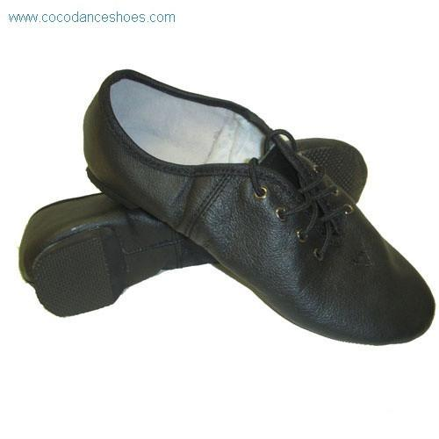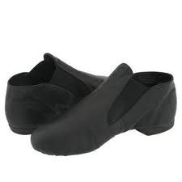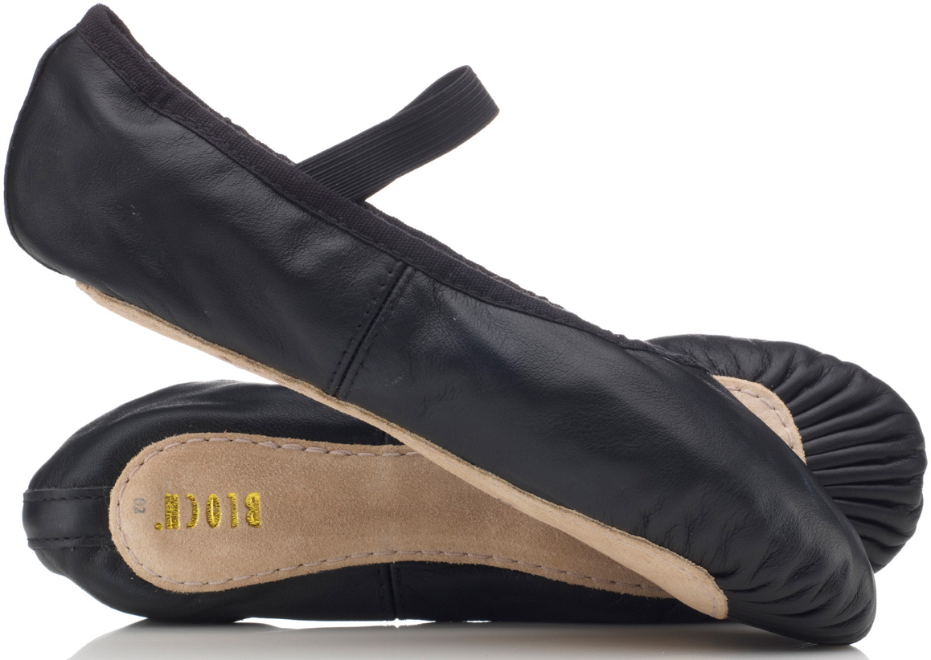
- Pictured above are the three types of dance shoes that are acceptable for the dance club. For the safety of the dancer we need this to be followed! ALL SHOES MUST BE BLACK/TAN FOR RECITAL!!

- Ballet “slippers” are not acceptable! See below…they are the ones with the soft cushion sole
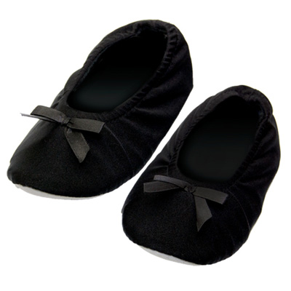
***For all middle school dancers it will be up to the instructors if they want you to purchase and/or use dance paws. Please ask them before wearing them.

